**Faculty of Computing**

**CS110: Fundamentals of Computer Programming**

**Lab 03: Basic I/O, Variables, Datatypes and Operators**

**Date: 26th September, 2025**

**Time: 10:00 AM- 1:00 PM**

**Instructor: Ms. Nazia Perwaiz**

**Lab Engineer: Mr. Khurram Saeed**

**Learning Objectives**

After completing this section you will be able to:

1. Do variable declarations and initializations.
2. Get input from keyboard using cin()
3. Perform arithmetic in C++

# Lab Tasks

1. Produce the following output

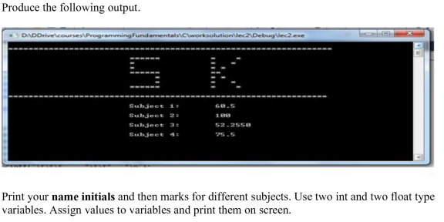

1. Write a program that inputs three different integers from the keyboard, and then prints the sum, the average, the product. The screen dialogue should appear as follows:

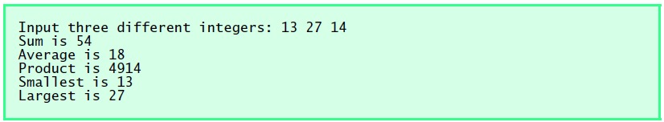

1. The distance between two cities (in km.) is input through the keyboard. Write a program to convert and print this distance in meters, feet, inches and centimeters.
2. Input two numbers, increment the first and decrement the second, then display both.
3. Using only the techniques you learned in this chapter, write a program that calculates the squares and cubes of the numbers from 0 to 10 and uses tabs to print the following table of values:

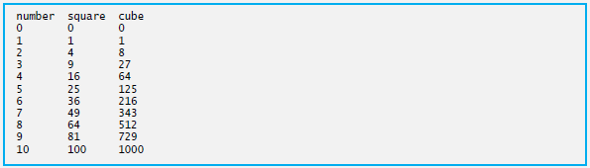

1. Write a C++ program that takes three integers as input and determines whether exactly one of them is positive using only logical operators ( &&, ||, ! ) and arithmetic expressions.

You must not use if, switch, the ternary operator ?:, or any kind of loop. The output should be 1 if exactly one number is positive, and 0 otherwise.

1. Input two numbers. Print which one is greater using only relational operators (not if/else).